1. 
2. Let’s find the point with 3Q.
3. 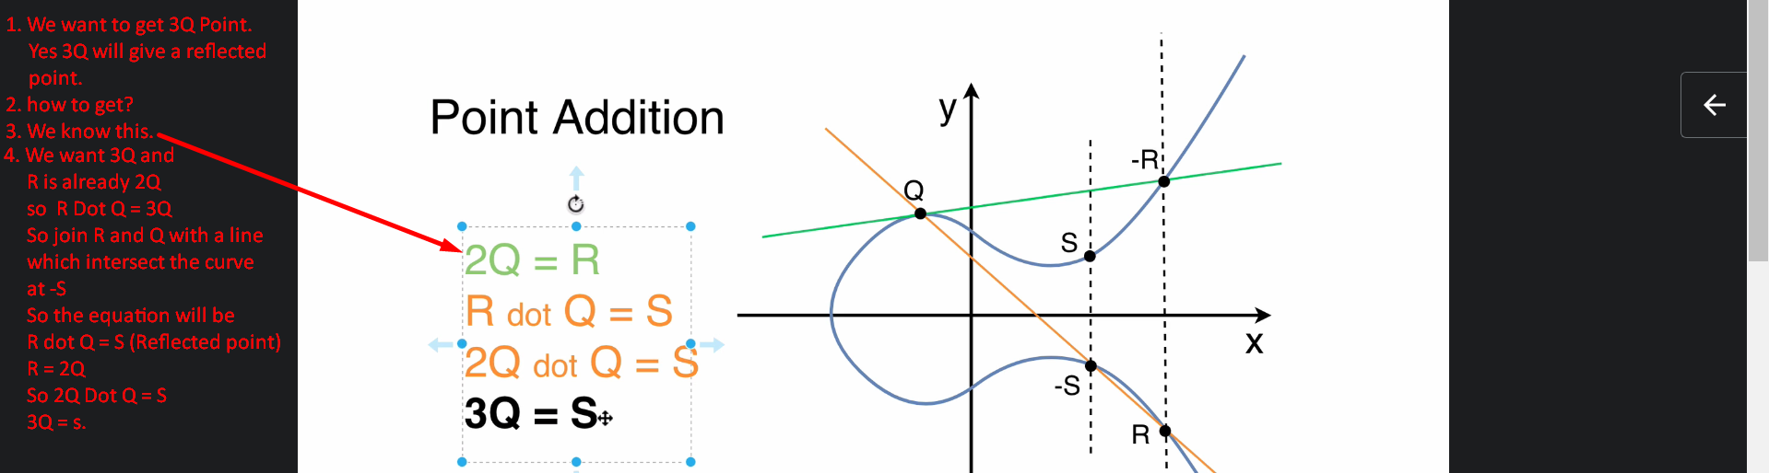  
     
     
   
4. Can we get 4Q?
5. We have request 3Q = S  
   So to get 4Q, just do this -> Q dot S = something which will give 4Q = something.  
   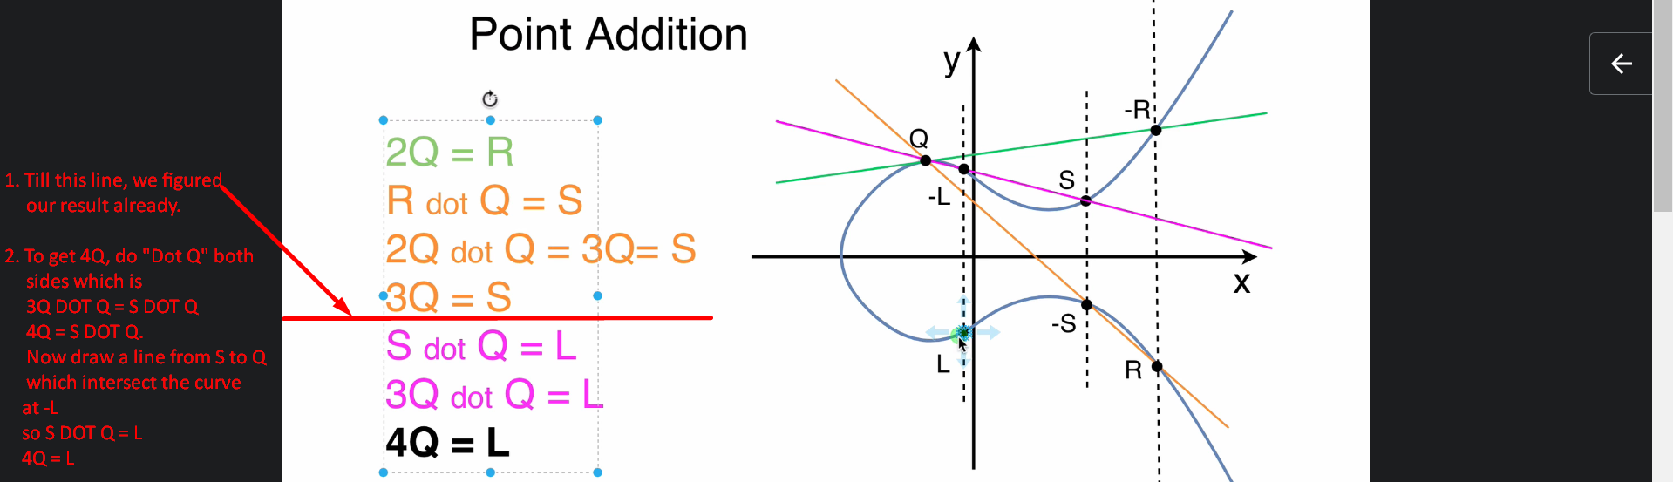
6. 
7. Answer: Yes.
8. Let’s see in next lecture.